Our Life with Animals
FIRST SCREEN
Kate calls Lucy.
Kate: “Hi, Lucy. Do you want to go to the cinema today?”
Lucy: “Hi, Kate. Yes, I do. What film do you want?”
Kate: “A film about animals. The film is Our Life with Animals.”
Lucy: “Great! I love animal films. I call Peter and Tom.”
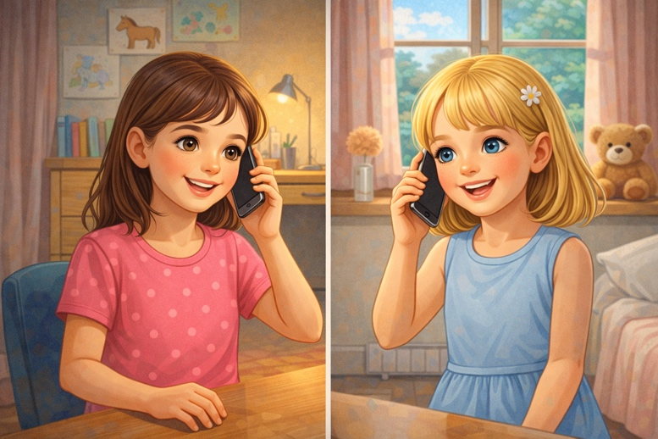
Lucy calls Peter.
Lucy: “Hi, Peter. We go to the cinema. Do you want to go with us?”
Peter: “Hi, Lucy. Yes, I want to go. I like animals. What time do we meet?”
Lucy: “We meet at four o’clock, near the park.”
Peter: “Good. I call Tom.”
Peter calls Tom.
Peter: “Hi, Tom. We meet Kate and Lucy. We go to the cinema.”
Tom: “Hi, Peter! Yes, I come. I love animals in the zoo.”
Peter: “Me too. We walk in the park first.”
Tom: “Perfect!”

SECOND SCREEN
They meet near the park.
Kate: “Hi everyone!”
Lucy, Peter, Tom: “Hi!”
They start to walk through the park. The day is nice. Lucy sees a dog.Lucy: “Look! A dog. It is very big.”
They hear birds in the trees.
Tom: “I hear birds.”
Peter: “Yes. Birds sing. I like it.”
Lucy: “They are nice. The colors! Blue, green, yellow, white...”
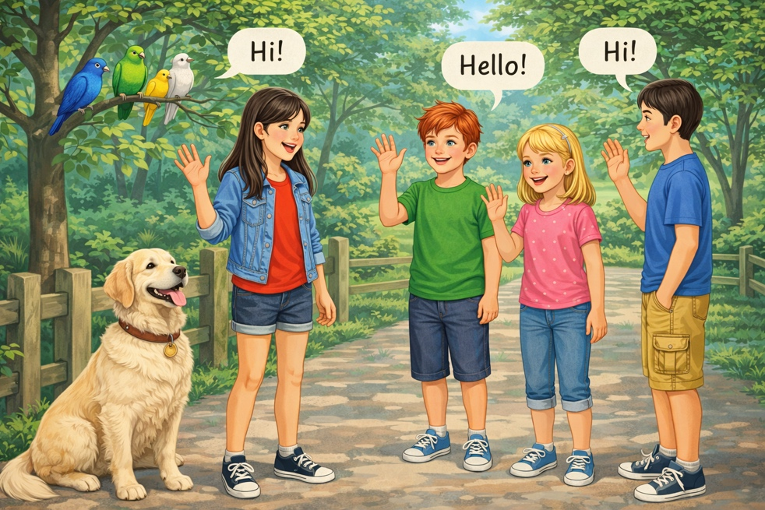

THIRD SCREEN
They walk to a small pond.
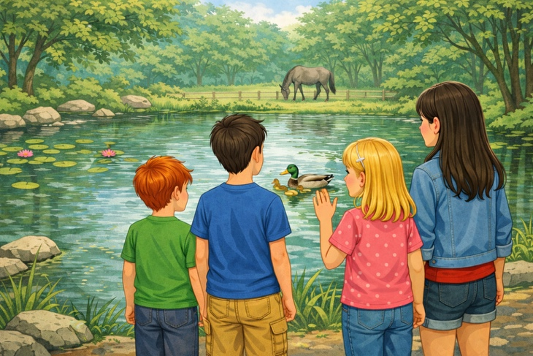

Lucy: “Look, ducks!”
Kate: “Two small ducks and one big duck.”
Tom: “And look—fish in the water!”
Peter: “It is red, Tom. It is very nice”.
Now they see a horse in a field.
Kate: “Is that a horse?”
Lucy: “Yes, a horse. It is grey and black.”
Tom: “I like horses. And I like cows too.”
Peter: “And I like sheep and goats.”
FOURTH SCREEN
At the cinema they buy tickets.
Peter: “Four tickets, please.”
Lucy: “And we buy popcorn.”
Tom: “I buy a drink.”
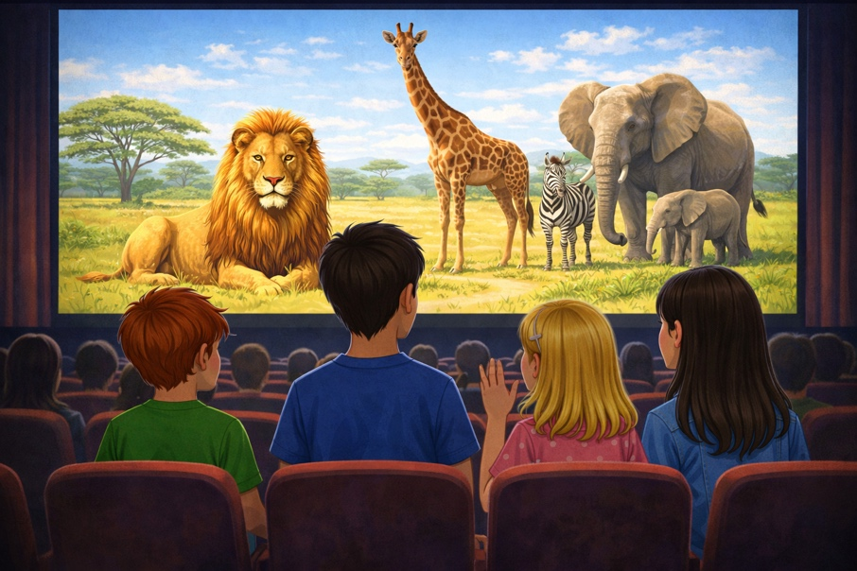
Lucy: “Look, a lion!”
Peter: “And look—a giraffe. It is very tall.”
Kate: “I like the zebra. Black and white.
Lucy: “The Elephants are grey and big.”
Peter: “Yes, and very smart.”
Tom: “I like the baby elephant.”
FIFTH SCREEN
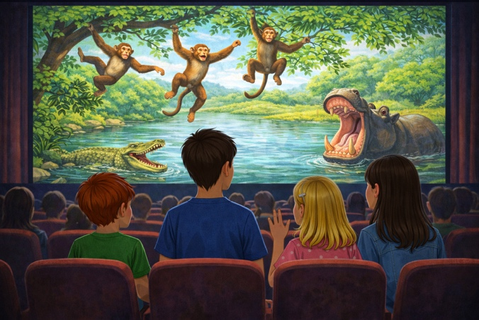
Kate: “Monkeys are funny.”
Tom: “They jump and run!”
Lucy: “The crocodile is dangerous.”
Kate: “Yes, but the hippo is dangerous too.”
Tom: “The hippo is big, but it looks slow.”
Peter: “In water it is fast.”
SIXTH SCREEN
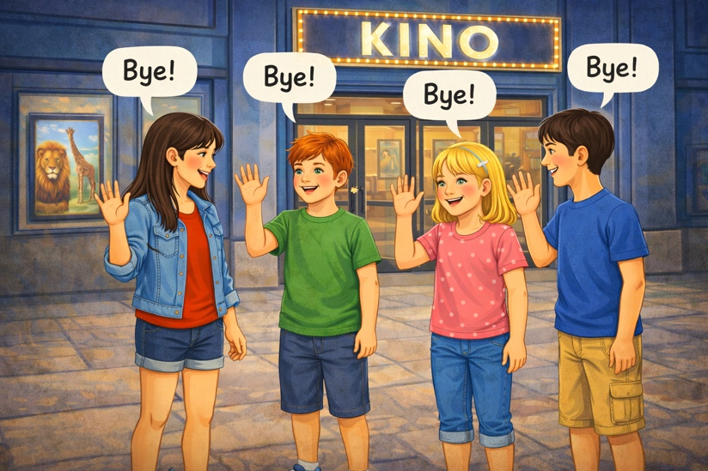
Kate: “The film is really good.”
Lucy: “Yes. I love the lion and the elephant.”
Tom: “I love the giraffe and the monkey.”
Peter: “I love the zebra and the crocodile.”
Kate: “Now I want to go to the zoo.”
Lucy: “Me too! We go another day.”
Tom: “Yes! We see lions, elephants, giraffes, zebras and monkeys…”
Peter: “And maybe we see rhinos too.”
They smile. All say bye. They go home.

